**Uploading V4 Arduino logger software:**

1. Download arduino\_logger\_v4.zip from: [http://firmware.makerbot.com/g5/arduino\_logger\_v4.zip](http://firmware.makerbot.com/g5/arduino_logger_v4.zip" \t "_blank)
2. Extract files
3. Open the resulting “arduino\_logger” folder. There should be three .pde files inside:

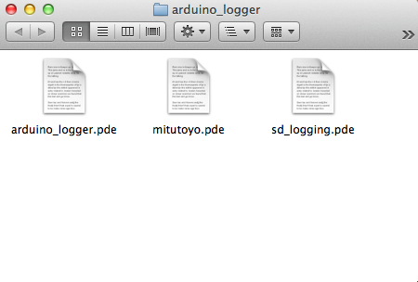

1. Open the Arduino application.

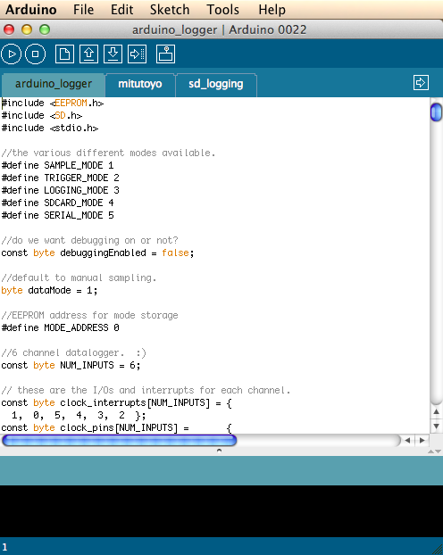

1. Connect Arduino PCB to computer via USB port.
2. Under the tools menu, select the correct serial port for that the arduino USB cable is connected to.
3. Under the tools>board menu, select “Arduino Mega 2560”:

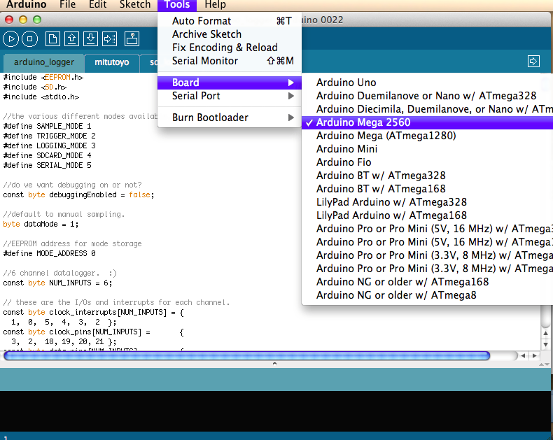

1. Click on the compile button inside the Arduino software. (It has a triangle symbol)

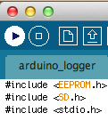

1. If the code compiles correctly, it will say so at the bottom of the Arduino window.

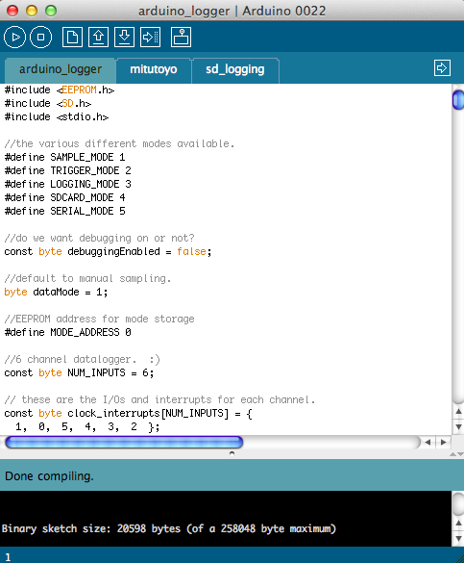

1. Click on the upload button to upload the code to the Arduino. You will also see an upload complete confirmation at the bottom of the Arduino window if it performed correctly.

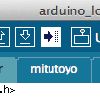

1. **完了！！** The Arduino is now ready to connect to an EP1 machine with Gen5 electronics. There is no need to use a computer to run the accuracy tests anymore, since the data collected will write directly to the USB drive. Be sure to have power connected to the Arduino, and connect to the EP1 machine with a USB hub like the image below.

